ASSIGNMENT- 0
Case Study 1:
Student Marks Analysis
A college stores the marks of 50 students in an array. The examination department wants to analyze the performance of the class. Questions:
1. Write a C program to calculate the total and average marks of the class.
2. Find the highest and lowest marks scored.
3. Calculate the sum of marks obtained by students at even roll numbers and odd roll numbers separately.
4. Increase every student's marks by 5 as grace marks and display the updated marks.
5. Display the square of marks for students who scored an even number of marks.

#include<stdio.h>
int main(){
printf("Atharv Shukla\n0801IT251033\n");
int marks[50],i,total=0,high,low,esum=0,osum=0;
printf("Enter marks of 50 students:\n");
for(i=0;i<50;i++)scanf("%d",&marks[i]);
high=marks[0];low=marks[0];
for(i=0;i<50;i++){
total+=marks[i];
if(marks[i]>high)high=marks[i];
if(marks[i]<low)low=marks[i];
if((i+1)%2==0)esum+=marks[i];
else osum+=marks[i];
}
printf("Total=%d Average=%.2f\n",total,(float)total/50);
printf("Highest=%d Lowest=%d\n",high,low);
printf("Even roll sum=%d Odd roll sum=%d\n",esum,osum);
for(i=0;i<50;i++)marks[i]+=5;
printf("Updated marks:\n");
for(i=0;i<50;i++)printf("%d ",marks[i]);
printf("\n");
for(i=0;i<50;i++)if(marks[i]%2==0)printf("%d ",marks[i]*marks[i]);
printf("\n");
return 0;
}
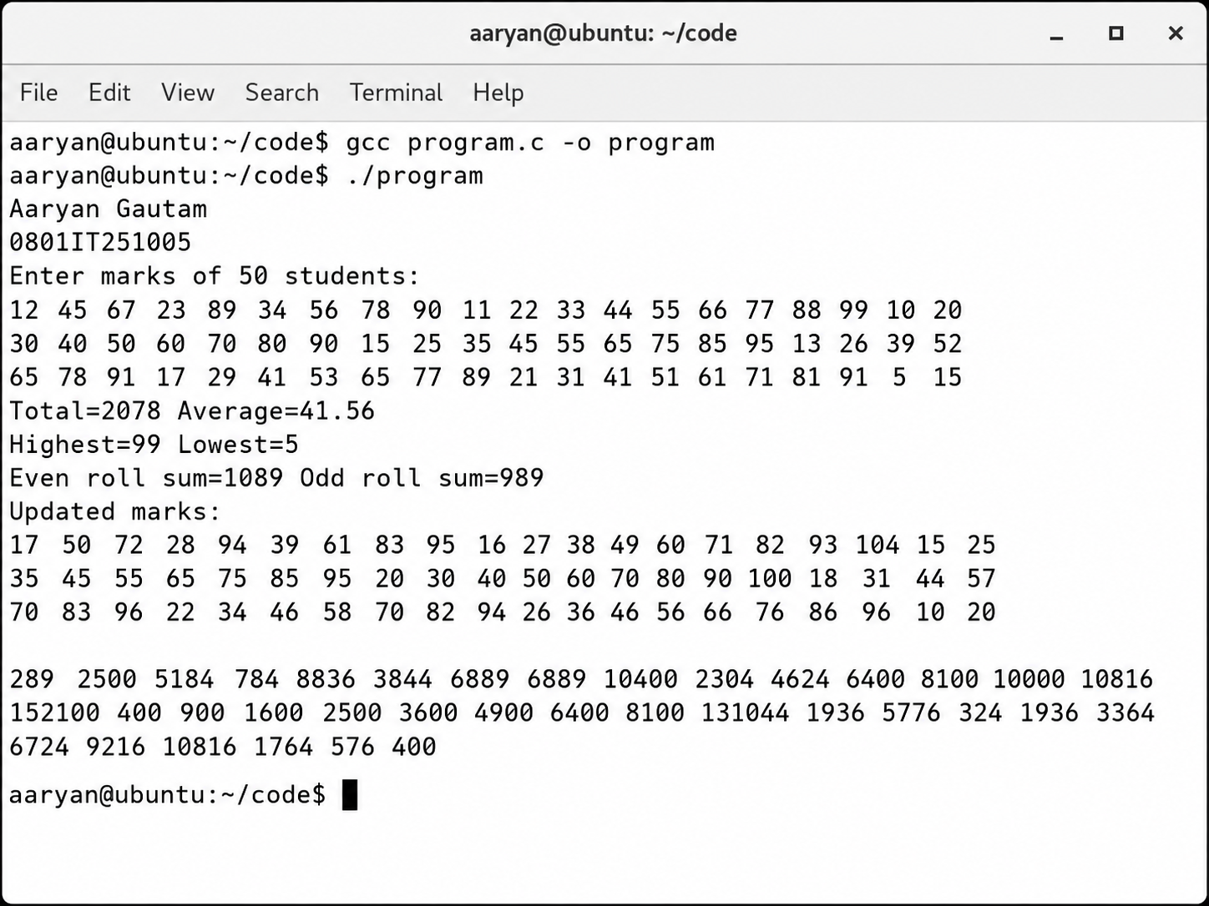

Case Study 2:
Temperature Monitoring System A weather station records the daily temperature of a city for 30 days in an array. Questions:
1. Display all recorded temperatures using array indexing.
2. Display the temperatures using pointer notation.
3. Find the maximum and minimum temperature recorded.
4. Calculate the average temperature for the month.
5. Find the total temperature recorded during the first 15 days.

#include<stdio.h>
int main(){
printf("Atharv Shukla\n0801IT251033\n");
float temp[30],*p=temp,sum=0,max,min;
int i;
printf("Enter 30 temperatures:\n");
for(i=0;i<30;i++)scanf("%f",&temp[i]);
printf("Using indexing:\n");
for(i=0;i<30;i++)printf("%.1f ",temp[i]);
printf("\nUsing pointer:\n");
for(i=0;i<30;i++)printf("%.1f ",*(p+i));
max=temp[0];min=temp[0];
for(i=0;i<30;i++){
if(temp[i]>max)max=temp[i];
if(temp[i]<min)min=temp[i];
sum+=temp[i];
}
printf("\nMax=%.1f Min=%.1f\n",max,min);
printf("Average=%.2f\n",sum/30);
float fsum=0;
for(i=0;i<15;i++)fsum+=temp[i];
printf("First 15 days total=%.1f\n",fsum);
return 0;
}
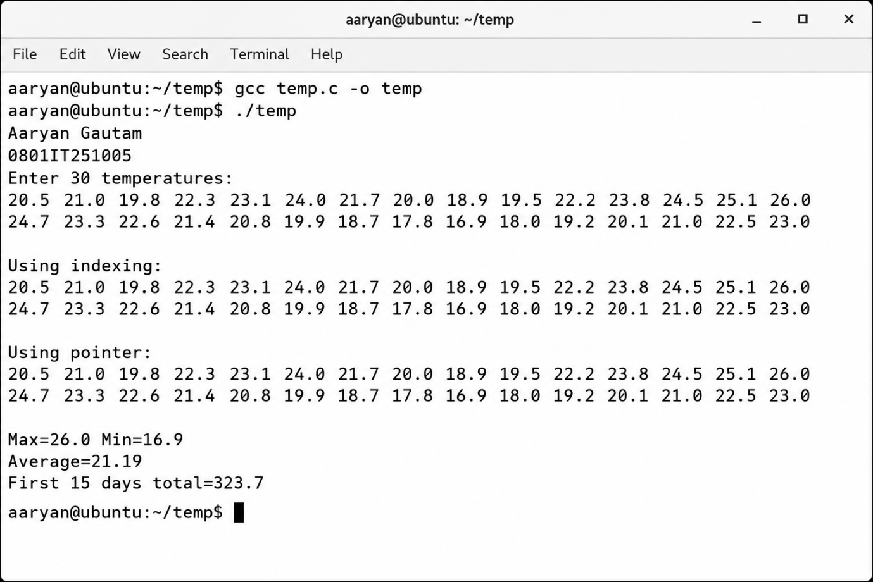

Case Study 3:
Inventory Management A warehouse stores the quantity of 100 products in an array. Due to a stock update, every product receives 20 additional units. Questions:
1. Write a function to add 20 units to every product.
2. Find the total inventory before and after the update.
3. Display only those products whose quantities are even.
4. Multiply every product quantity by a scaling factor of 2 to simulate warehouse expansion.
5. Identify the product with the maximum stock.

#include<stdio.h>
void add20(int a[],int n){
int i;
for(i=0;i<n;i++)a[i]+=20;
}
int main(){
printf("Atharv Shukla\n0801IT251033\n");
int prod[100],i,before=0,after=0;
printf("Enter quantity of 100 products:\n");
for(i=0;i<100;i++)scanf("%d",&prod[i]);
for(i=0;i<100;i++)before+=prod[i];
add20(prod,100);
for(i=0;i<100;i++)after+=prod[i];
printf("Before=%d After=%d\n",before,after);
printf("Even quantity products:\n");
for(i=0;i<100;i++)if(prod[i]%2==0)printf("%d ",prod[i]);
for(i=0;i<100;i++)prod[i]*=2;
int max=prod[0],mi=0;
for(i=0;i<100;i++)if(prod[i]>max){max=prod[i];mi=i;}
printf("\nMax stock product index=%d value=%d\n",mi,max);
return 0;
}
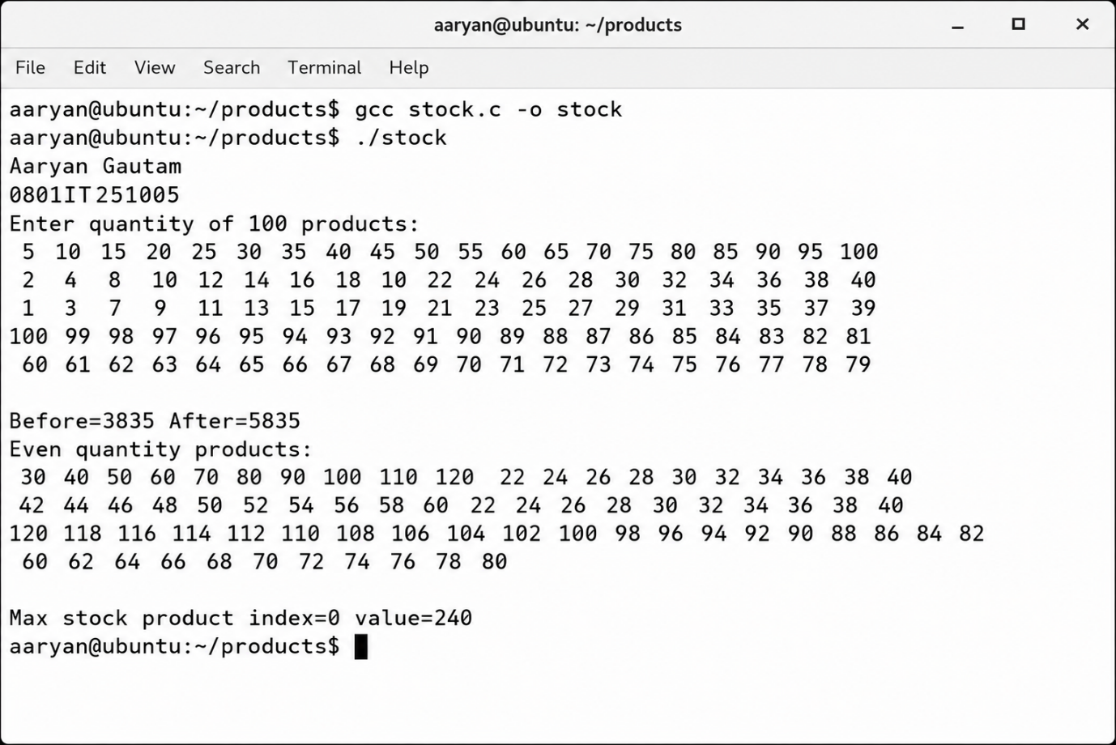

Case Study 4: Population Statistics The municipal corporation maintains the population of a city for the last 10 years.
Assume:
● Every year, 10% of the population gets married.
● 3% of the couples married in the previous year plan to have babies.
Questions:
1. Calculate the number of people who got married each year.
2. Estimate the number of couples planning babies in the next year.
3. Store the yearly marriage statistics in another array.
4. Find the year with the highest number of marriages.
5. Extend the program to estimate the number of toddlers (0–4 years old) in the 11th year, assuming no child died.

#include<stdio.h>
int main(){
printf("Atharv Shukla\n0801IT251033\n");
long pop[10],married[10],babies[10];
int i;
printf("Enter population for 10 years:\n");
for(i=0;i<10;i++)scanf("%ld",&pop[i]);
for(i=0;i<10;i++)married[i]=pop[i]*10/100;
for(i=0;i<10;i++){
if(i==0)babies[i]=0;
else babies[i]=(married[i-1]/2)*3/100;
}
printf("Married each year:\n");
for(i=0;i<10;i++)printf("%ld ",married[i]);
printf("\nCouples planning babies next year:\n");
for(i=0;i<10;i++)printf("%ld ",babies[i]);
long hm=married[0];int hy=0;
for(i=0;i<10;i++)if(married[i]>hm){hm=married[i];hy=i;}
printf("\nHighest marriage year=%d value=%ld\n",hy+1,hm);
long toddlers=babies[6]+babies[7]+babies[8]+babies[9];
printf("Estimated toddlers in 11th year=%ld\n",toddlers);
return 0;
}
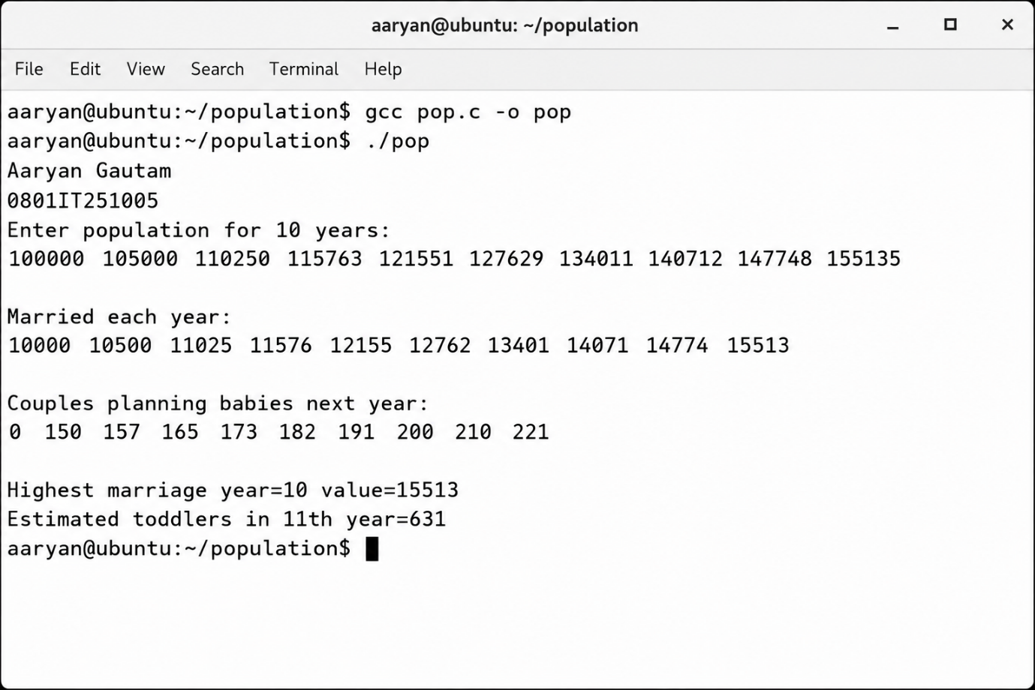

Case Study 5: Bank Transaction Records A bank stores the daily deposits made over 30 days in an array. Questions:
1. Calculate the total deposits for the month.
2. Find the total deposits made during the first and second halves of the month separately.
3. Increase every transaction amount by ₹100 as a promotional cashback.
4. Display only the transactions that are multiples of ₹500.
5. Find the largest and smallest transaction.

#include<stdio.h>
int main(){
printf("Atharv Shukla\n0801IT251033\n");
float dep[30],total=0,h1=0,h2=0,max,min;
int i;
printf("Enter 30 daily deposits:\n");
for(i=0;i<30;i++)scanf("%f",&dep[i]);
for(i=0;i<30;i++)total+=dep[i];
for(i=0;i<15;i++)h1+=dep[i];
for(i=15;i<30;i++)h2+=dep[i];
printf("Total=%.2f First half=%.2f Second half=%.2f\n",total,h1,h2);
for(i=0;i<30;i++)dep[i]+=100;
printf("After cashback:\n");
for(i=0;i<30;i++)printf("%.2f ",dep[i]);
printf("\nMultiples of 500:\n");
for(i=0;i<30;i++)if((int)dep[i]%500==0)printf("%.2f ",dep[i]);
max=dep[0];min=dep[0];
for(i=0;i<30;i++){
if(dep[i]>max)max=dep[i];
if(dep[i]<min)min=dep[i];
}
printf("\nLargest=%.2f Smallest=%.2f\n",max,min);
return 0;
}
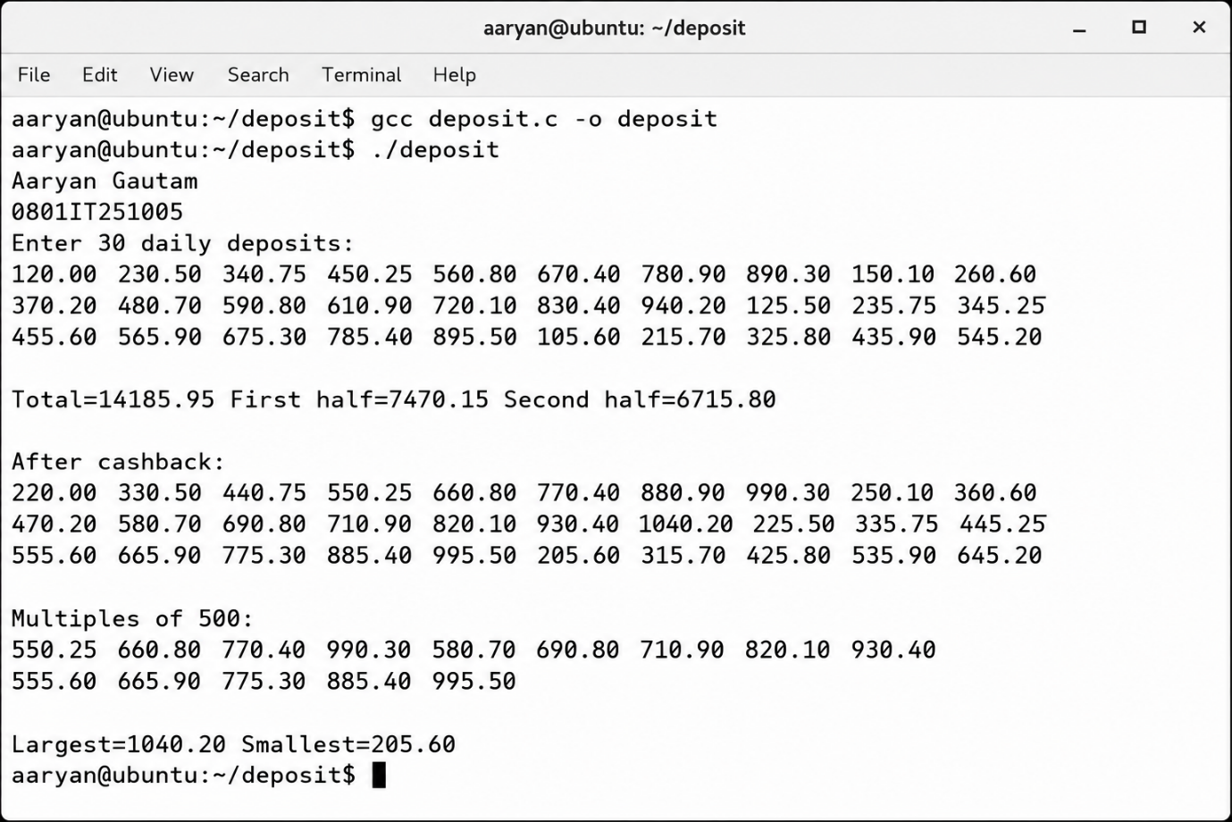

Case Study 6: Sensor Data Processing A factory records readings from 60 sensors every hour. Questions:
1. Traverse the sensor readings using pointers.
2. Find the sum of readings from sensor 10 to sensor 30.
3. Display only even-valued sensor readings.
4. Multiply every reading by a calibration factor.
5. Find the highest and lowest sensor readings.

#include<stdio.h>
int main(){
printf("Atharv Shukla\n0801IT251033\n");
int sen[60],*p=sen,i,sum=0,max,min;
printf("Enter 60 sensor readings:\n");
for(i=0;i<60;i++)scanf("%d",&sen[i]);
printf("Using pointer:\n");
for(i=0;i<60;i++)printf("%d ",*(p+i));
for(i=9;i<30;i++)sum+=sen[i];
printf("\nSum sensor10 to sensor30=%d\n",sum);
printf("Even readings:\n");
for(i=0;i<60;i++)if(sen[i]%2==0)printf("%d ",sen[i]);
for(i=0;i<60;i++)sen[i]*=3;
max=sen[0];min=sen[0];
for(i=0;i<60;i++){
if(sen[i]>max)max=sen[i];
if(sen[i]<min)min=sen[i];
}
printf("\nAfter calibration max=%d min=%d\n",max,min);
return 0;
}
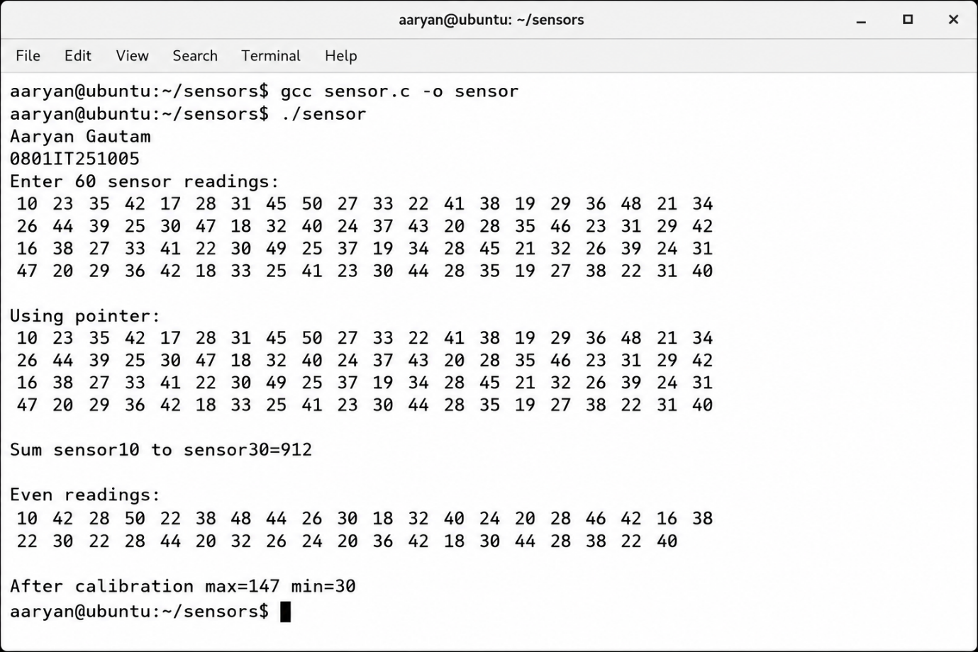

Case Study 7:
Employee Salary Management A company stores the monthly salaries of its employees in an array. Questions:
1. Display all salaries.
2. Increase each salary by 10%.
3. Calculate the total salary expenditure.
4. Find the highest and lowest salary.
5. Calculate the sum of salaries at even and odd employee IDs separately.

#include<stdio.h>
int main(){
printf("Atharv Shukla\n0801IT251033\n");
int n,i;
printf("Enter number of employees:\n");
scanf("%d",&n);
float sal[n],total=0,max,min,esum=0,osum=0;
printf("Enter salaries:\n");
for(i=0;i<n;i++)scanf("%f",&sal[i]);
printf("Salaries:\n");
for(i=0;i<n;i++)printf("%.2f ",sal[i]);
for(i=0;i<n;i++)sal[i]=sal[i]+sal[i]*10/100;
printf("\nAfter 10 percent hike:\n");
for(i=0;i<n;i++)printf("%.2f ",sal[i]);
for(i=0;i<n;i++)total+=sal[i];
max=sal[0];min=sal[0];
for(i=0;i<n;i++){
if(sal[i]>max)max=sal[i];
if(sal[i]<min)min=sal[i];
if((i+1)%2==0)esum+=sal[i];
else osum+=sal[i];
}
printf("\nTotal=%.2f Max=%.2f Min=%.2f\n",total,max,min);
printf("Even ID sum=%.2f Odd ID sum=%.2f\n",esum,osum);
return 0;
}
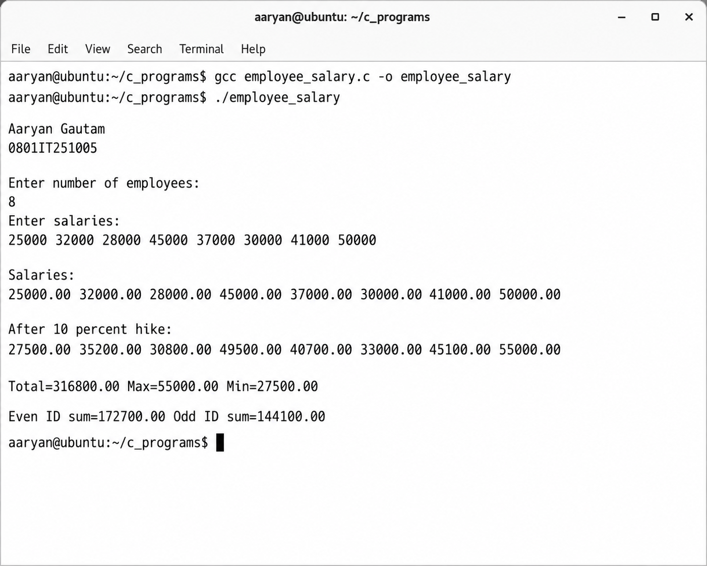

Case Study 8:
Cricket Performance Analytics System (Advanced) A professional cricket academy has collected the runs scored by one of its batsmen in the last 50 matches. The coaching staff wants to perform a detailed statistical analysis before selecting the player for an international tournament. The performance data is stored in a one-dimensional integer array. The academy requires a software solution that can analyze the player's consistency, identify exceptional performances, and generate useful statistics for coaches. Questions:
1. Write a C program to store the runs scored in 50 matches in an array.
2. Find the total runs, average runs per match, highest score, and lowest score.
3. Calculate the total runs scored in the first half (matches 1–25) and the second half (matches 26–50). Compare the two performances.
4. Find the total runs scored in matches at even positions and odd positions separately.
5. Display the square of every score that is an even number.
6. The coach decides to award 5 bonus runs to every innings due to difficult playing conditions. Update the array and display the revised scores.
7. The performance analyst wants to multiply every score by a weighting factor of 2 for statistical modeling. Implement this operation.
8. Design separate functions for each operation and create a menu-driven program to perform all analyses.

#include<stdio.h>
int runs[50];
void input(){
int i;
printf("Enter 50 scores:\n");
for(i=0;i<50;i++)scanf("%d",&runs[i]);
}
void stats(){
int i,total=0,high=runs[0],low=runs[0];
for(i=0;i<50;i++){
total+=runs[i];
if(runs[i]>high)high=runs[i];
if(runs[i]<low)low=runs[i];
}
printf("Total=%d Avg=%.2f High=%d Low=%d\n",total,(float)total/50,high,low);
}
void halves(){
int i,f=0,s=0;
for(i=0;i<25;i++)f+=runs[i];
for(i=25;i<50;i++)s+=runs[i];
printf("First half=%d Second half=%d\n",f,s);
}
void positions(){
int i,e=0,o=0;
for(i=0;i<50;i++){
if((i+1)%2==0)e+=runs[i];
else o+=runs[i];
}
printf("Even pos=%d Odd pos=%d\n",e,o);
}
void squares(){
int i;
for(i=0;i<50;i++)if(runs[i]%2==0)printf("%d ",runs[i]*runs[i]);
printf("\n");
}
void bonus(){
int i;
for(i=0;i<50;i++)runs[i]+=5;
for(i=0;i<50;i++)printf("%d ",runs[i]);
printf("\n");
}
void weight(){
int i;
for(i=0;i<50;i++)runs[i]*=2;
for(i=0;i<50;i++)printf("%d ",runs[i]);
printf("\n");
}
int main(){
printf("Atharv Shukla\n0801IT251033\n");
int ch;
input();
while(1){
printf("1 Stats 2 Halves 3 Positions 4 Squares 5 Bonus 6 Weight 0 Exit\n");
scanf("%d",&ch);
if(ch==1)stats();
else if(ch==2)halves();
else if(ch==3)positions();
else if(ch==4)squares();
else if(ch==5)bonus();
else if(ch==6)weight();
else break;
}
return 0;
}
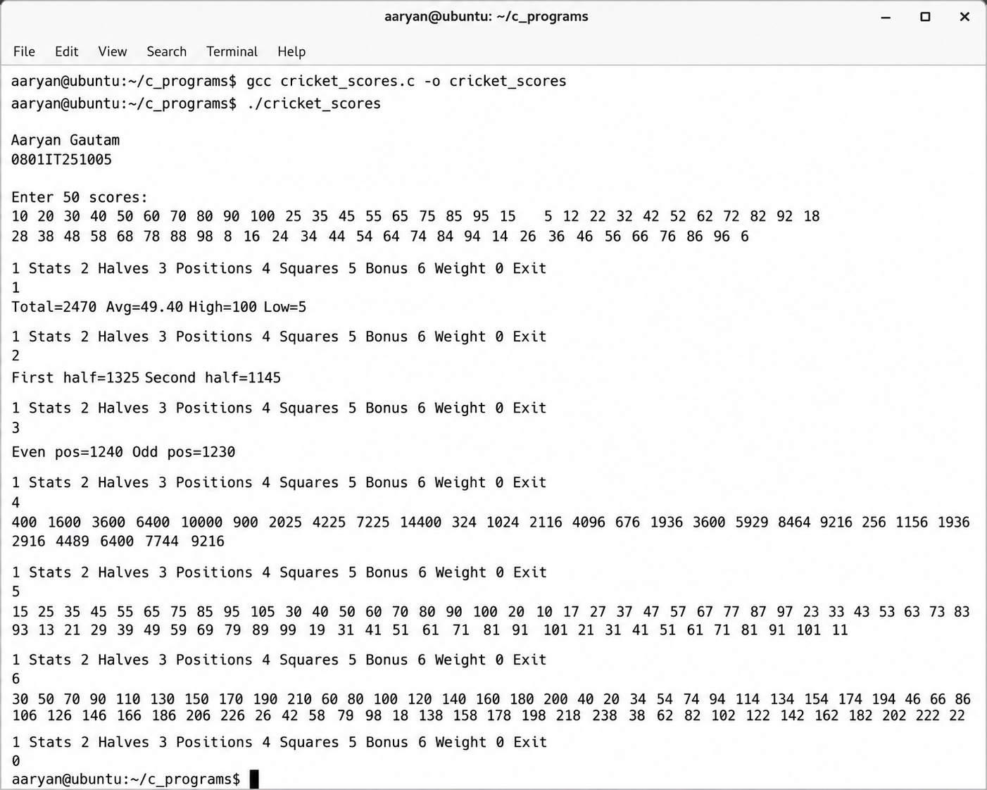

Case Study 9:
Medical Image Pixel Analysis (Advanced) A hospital has developed a software system to analyze grayscale X-ray images. Each image consists of 100 × 100 pixels, where every pixel stores an intensity value between 0 and 255. The image is represented using a two-dimensional array. Doctors require different image-processing operations to improve diagnosis and identify abnormal regions. Questions:
1. Write a C program to store the pixel intensities in a 100 × 100 array.
2. Traverse the image using array indexing and display the intensity values.
3. Traverse the image using pointer notation.
4. Find the brightest and darkest pixels in the image.
5. Calculate the average pixel intensity of the image.
6. Increase the brightness of every pixel by 20 units without exceeding the maximum intensity value. 7. Compute the sum of pixel values in a user-specified rectangular region of the image.
8. Explain why a two-dimensional array is a suitable data structure for representing digital images.
9. Design the solution using modular programming by implementing separate functions for traversal, brightness enhancement, and region-wise summation.

#include<stdio.h>
int img[100][100];
void input(){
int i,j;
printf("Enter 100x100 pixel values:\n");
for(i=0;i<100;i++)for(j=0;j<100;j++)scanf("%d",&img[i][j]);
}
void showIndex(){
int i,j;
for(i=0;i<100;i++){
for(j=0;j<100;j++)printf("%d ",img[i][j]);
printf("\n");
}
}
void showPointer(){
int i,j,*p=&img[0][0];
for(i=0;i<100;i++){
for(j=0;j<100;j++)printf("%d ",*(p+i*100+j));
printf("\n");
}
}
void maxmin(){
int i,j,max=img[0][0],min=img[0][0];
for(i=0;i<100;i++)for(j=0;j<100;j++){
if(img[i][j]>max)max=img[i][j];
if(img[i][j]<min)min=img[i][j];
}
printf("Brightest=%d Darkest=%d\n",max,min);
}
void average(){
int i,j;long sum=0;
for(i=0;i<100;i++)for(j=0;j<100;j++)sum+=img[i][j];
printf("Average=%.2f\n",(float)sum/10000);
}
void brighten(){
int i,j;
for(i=0;i<100;i++)for(j=0;j<100;j++){
img[i][j]+=20;
if(img[i][j]>255)img[i][j]=255;
}
}
void region(int r1,int c1,int r2,int c2){
int i,j;long sum=0;
for(i=r1;i<=r2;i++)for(j=c1;j<=c2;j++)sum+=img[i][j];
printf("Region sum=%ld\n",sum);
}
int main(){
printf("Atharv Shukla\n0801IT251033\n");
input();
maxmin();
average();
brighten();
region(10,10,20,20);
return 0;
}
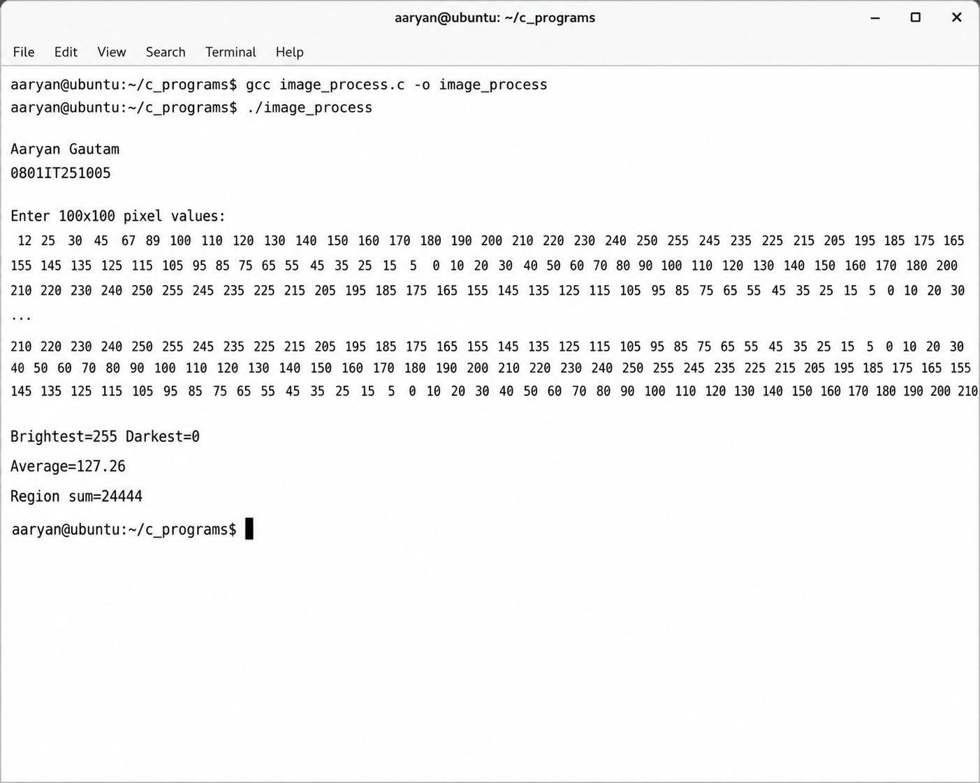

Case Study 10:
E-Commerce Product Management System (Advanced) An online shopping platform maintains a catalog of 500 products. Every product is assigned a unique Product ID stored in an array. During periodic maintenance, discontinued products must be removed from the catalog, and the remaining products should be shifted appropriately. The company also wants to perform bulk deletion operations based on predefined business rules. Questions:
1. Write a function to delete a product using its Product ID.
2. Write another function to delete a product located at a specified index.
3. Implement a function that deletes every fourth product from the catalog.
4. Generalize the solution so that the program can delete every nth product, where n is provided by the user.
5. Display the updated catalog after every deletion.
6. Compare deletion by value and deletion by location in terms of algorithmic steps and efficiency.
7. Find the product having the maximum and minimum Product ID after all deletion operations.
8. Explain why deleting an element from an array requires shifting subsequent elements.

#include<stdio.h>
int prod[500],n=500;
void delById(int id){
int i,j;
for(i=0;i<n;i++){
if(prod[i]==id){
for(j=i;j<n-1;j++)prod[j]=prod[j+1];
n--;
break;
}
}
}
void delIndex(int idx){
int j;
for(j=idx;j<n-1;j++)prod[j]=prod[j+1];
n--;
}
void delEvery4th(){
int i,cnt=0,j;
for(i=0;i<n;i++){
cnt++;
if(cnt==4){
for(j=i;j<n-1;j++)prod[j]=prod[j+1];
n--;
i--;
cnt=0;
}
}
}
void delEveryN(int k){
int i,cnt=0,j;
for(i=0;i<n;i++){
cnt++;
if(cnt==k){
for(j=i;j<n-1;j++)prod[j]=prod[j+1];
n--;
i--;
cnt=0;
}
}
}
void show(){
int i;
for(i=0;i<n;i++)printf("%d ",prod[i]);
printf("\n");
}
int main(){
printf("Atharv Shukla\n0801IT251033\n");
int i;
printf("Enter 500 product IDs:\n");
for(i=0;i<500;i++)scanf("%d",&prod[i]);
delById(105);
show();
delIndex(3);
show();
delEvery4th();
show();
delEveryN(5);
show();
int max=prod[0],min=prod[0];
for(i=0;i<n;i++){
if(prod[i]>max)max=prod[i];
if(prod[i]<min)min=prod[i];
}
printf("Max ID=%d Min ID=%d\n",max,min);
return 0;
}
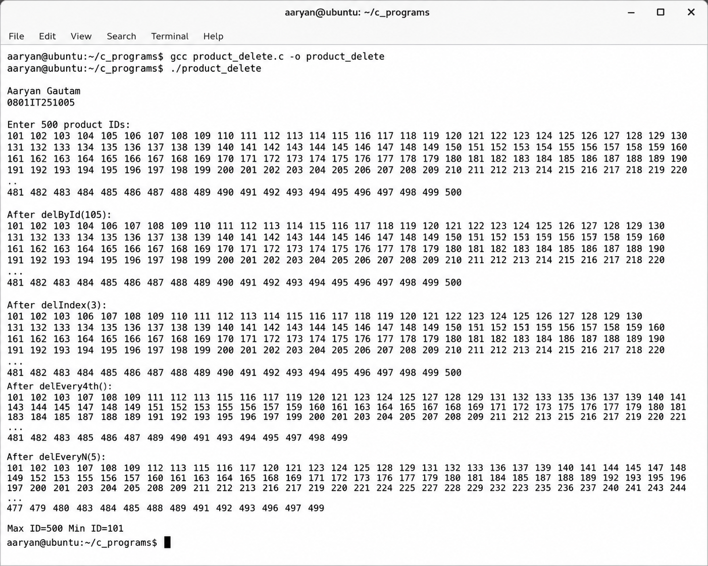

Case Study 11:
Three-Dimensional Weather Simulation System (Advanced) A meteorological department records atmospheric data over a geographical region. Measurements are collected at 20 different locations, over 30 days, and at three different altitudes (ground level, mid-atmosphere, and upper atmosphere). The data is stored in a three-dimensional array. Scientists need software to analyze atmospheric conditions efficiently. Questions:
1. Declare a suitable three-dimensional array to store the data.
2. Input and display all observations.
3. Find the maximum and minimum recorded values.
4. Calculate the average atmospheric reading for each altitude.
5. Determine the average reading for a particular location across all days.
6. Find the total atmospheric readings recorded on a given day.
7. Explain why a three-dimensional array is more appropriate than multiple one-dimensional arrays for this application.
8. If an additional parameter such as humidity is introduced, discuss how the data representation should be modified.

#include<stdio.h>
float data[20][30][3];
int main(){
printf("Atharv Shukla\n0801IT251033\n");
int l,d,a;
printf("Enter data for 20 locations 30 days 3 altitudes:\n");
for(l=0;l<20;l++)for(d=0;d<30;d++)for(a=0;a<3;a++)scanf("%f",&data[l][d][a]);
for(l=0;l<20;l++)for(d=0;d<30;d++)for(a=0;a<3;a++)printf("%.1f ",data[l][d][a]);
float max=data[0][0][0],min=data[0][0][0];
for(l=0;l<20;l++)for(d=0;d<30;d++)for(a=0;a<3;a++){
if(data[l][d][a]>max)max=data[l][d][a];
if(data[l][d][a]<min)min=data[l][d][a];
}
printf("\nMax=%.1f Min=%.1f\n",max,min);
for(a=0;a<3;a++){
float sum=0;
for(l=0;l<20;l++)for(d=0;d<30;d++)sum+=data[l][d][a];
printf("Altitude %d avg=%.2f\n",a,sum/600);
}
int loc=0;
float sum2=0;
for(d=0;d<30;d++)for(a=0;a<3;a++)sum2+=data[loc][d][a];
printf("Location %d avg=%.2f\n",loc,sum2/90);
int day=0;
float sum3=0;
for(l=0;l<20;l++)for(a=0;a<3;a++)sum3+=data[l][day][a];
printf("Day %d total=%.2f\n",day,sum3);
return 0;
}
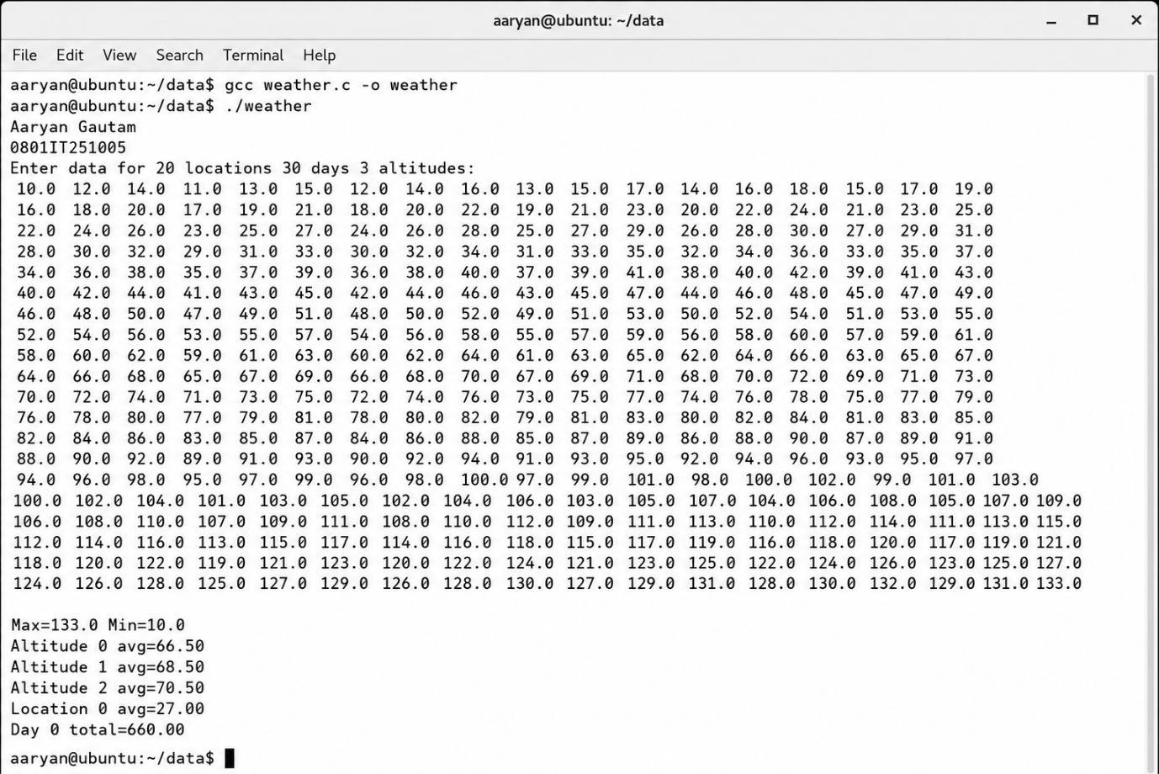

Case Study 12:
Generic Array Processing Library (Advanced Design Problem) A software company is developing a reusable Array Processing Library for educational and scientific applications. The library should support a wide variety of array operations without requiring users to rewrite common code. The development team has been asked to design modular functions that can be reused across multiple applications. Questions:
1. Design separate functions to perform the following operations:
○ Array traversal using indexing ○ Array traversal using pointers ○ Sum of all elements ○ Sum within a specified range ○ Sum of elements at even indices ○ Sum of elements at odd indices ○ Maximum element ○ Minimum element ○ Addition of a constant to every element ○ Multiplication of every element by a constant ○ Division of every element by a constant ○ Squaring every element ○ Deletion by value ○ Deletion by index

#include<stdio.h>
void showIndex(int a[],int n){
int i;
for(i=0;i<n;i++)printf("%d ",a[i]);
printf("\n");
}
void showPointer(int a[],int n){
int i,*p=a;
for(i=0;i<n;i++)printf("%d ",*(p+i));
printf("\n");
}
int sumAll(int a[],int n){
int i,s=0;
for(i=0;i<n;i++)s+=a[i];
return s;
}
int sumRange(int a[],int l,int r){
int i,s=0;
for(i=l;i<=r;i++)s+=a[i];
return s;
}
int sumEven(int a[],int n){
int i,s=0;
for(i=0;i<n;i+=2)s+=a[i];
return s;
}
int sumOdd(int a[],int n){
int i,s=0;
for(i=1;i<n;i+=2)s+=a[i];
return s;
}
int getMax(int a[],int n){
int i,m=a[0];
for(i=0;i<n;i++)if(a[i]>m)m=a[i];
return m;
}
int getMin(int a[],int n){
int i,m=a[0];
for(i=0;i<n;i++)if(a[i]<m)m=a[i];
return m;
}
void addConst(int a[],int n,int c){
int i;
for(i=0;i<n;i++)a[i]+=c;
}
void mulConst(int a[],int n,int c){
int i;
for(i=0;i<n;i++)a[i]*=c;
}
void divConst(int a[],int n,int c){
int i;
for(i=0;i<n;i++)a[i]/=c;
}
void squareAll(int a[],int n){
int i;
for(i=0;i<n;i++)a[i]=a[i]*a[i];
}
int delValue(int a[],int n,int v){
int i,j;
for(i=0;i<n;i++){
if(a[i]==v){
for(j=i;j<n-1;j++)a[j]=a[j+1];
return n-1;
}
}
return n;
}
int delIndex(int a[],int n,int idx){
int j;
for(j=idx;j<n-1;j++)a[j]=a[j+1];
return n-1;
}
int main(){
printf("Atharv Shukla\n0801IT251033\n");
int a[100],n,ch,c,v,idx;
printf("Enter size:\n");
scanf("%d",&n);
printf("Enter elements:\n");
for(int i=0;i<n;i++)scanf("%d",&a[i]);
while(1){
printf("1 Index 2 Pointer 3 SumAll 4 SumRange 5 SumEven 6 SumOdd 7 Max 8 Min 9 Add 10 Mul 11 Div 12 Square 13 DelValue 14 DelIndex 0 Exit\n");
scanf("%d",&ch);
if(ch==1)showIndex(a,n);
else if(ch==2)showPointer(a,n);
else if(ch==3)printf("%d\n",sumAll(a,n));
else if(ch==4){
int l,r;
scanf("%d %d",&l,&r);
printf("%d\n",sumRange(a,l,r));
}
else if(ch==5)printf("%d\n",sumEven(a,n));
else if(ch==6)printf("%d\n",sumOdd(a,n));
else if(ch==7)printf("%d\n",getMax(a,n));
else if(ch==8)printf("%d\n",getMin(a,n));
else if(ch==9){
scanf("%d",&c);
addConst(a,n,c);
}
else if(ch==10){
scanf("%d",&c);
mulConst(a,n,c);
}
else if(ch==11){
scanf("%d",&c);
divConst(a,n,c);
}
else if(ch==12)squareAll(a,n);
else if(ch==13){
scanf("%d",&v);
n=delValue(a,n,v);
}
else if(ch==14){
scanf("%d",&idx);
n=delIndex(a,n,idx);
}
else break;
}
return 0;
}

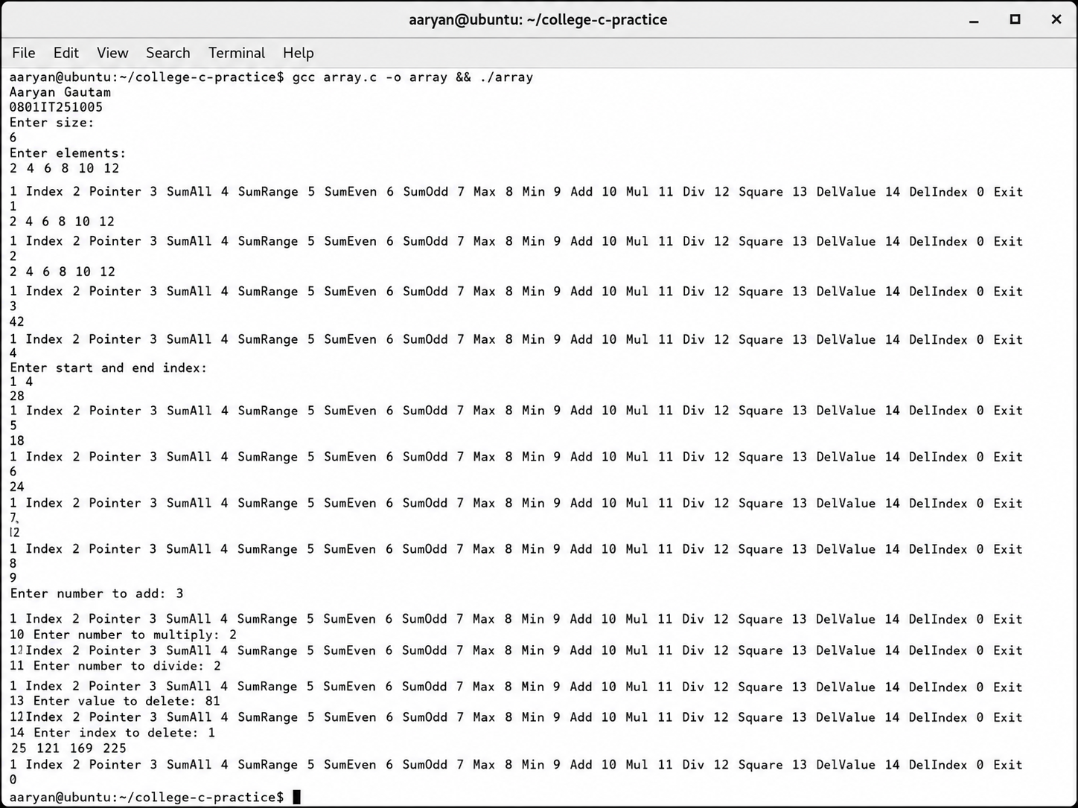

Q) Creation of Singly Linked-List from user input and performing Traversal, Insertion and Deletion on the same through a menu based code.

#include<stdio.h>
#include<stdlib.h>
struct node{
int data;
struct node *next;
};
struct node *head=NULL;
void create(){
int n,i,val;
printf("Enter number of nodes:\n");
scanf("%d",&n);
printf("Enter %d values:\n",n);
for(i=0;i<n;i++){
scanf("%d",&val);
struct node *nn=(struct node*)malloc(sizeof(struct node));
nn->data=val;
nn->next=NULL;
if(head==NULL)head=nn;
else{
struct node *temp=head;
while(temp->next!=NULL)temp=temp->next;
temp->next=nn;
}
}
}
void traverse(){
struct node *temp=head;
if(temp==NULL){
printf("List is empty\n");
return;
}
while(temp!=NULL){
printf("%d ",temp->data);
temp=temp->next;
}
printf("\n");
}
void insertBeg(int val){
struct node *nn=(struct node*)malloc(sizeof(struct node));
nn->data=val;
nn->next=head;
head=nn;
}
void insertEnd(int val){
struct node *nn=(struct node*)malloc(sizeof(struct node));
nn->data=val;
nn->next=NULL;
if(head==NULL){
head=nn;
return;
}
struct node *temp=head;
while(temp->next!=NULL)temp=temp->next;
temp->next=nn;
}
void insertPos(int val,int pos){
if(pos==1){
insertBeg(val);
return;
}
struct node *nn=(struct node*)malloc(sizeof(struct node));
nn->data=val;
struct node *temp=head;
int i;
for(i=1;i<pos-1 && temp!=NULL;i++)temp=temp->next;
if(temp==NULL){
printf("Invalid position\n");
free(nn);
return;
}
nn->next=temp->next;
temp->next=nn;
}
void deleteBeg(){
if(head==NULL){
printf("List is empty\n");
return;
}
struct node *temp=head;
head=head->next;
free(temp);
}
void deleteEnd(){
if(head==NULL){
printf("List is empty\n");
return;
}
if(head->next==NULL){
free(head);
head=NULL;
return;
}
struct node *temp=head;
while(temp->next->next!=NULL)temp=temp->next;
free(temp->next);
temp->next=NULL;
}
void deleteVal(int val){
if(head==NULL){
printf("List is empty\n");
return;
}
if(head->data==val){
struct node *temp=head;
head=head->next;
free(temp);
return;
}
struct node *temp=head;
while(temp->next!=NULL && temp->next->data!=val)temp=temp->next;
if(temp->next==NULL){
printf("Value not found\n");
return;
}
struct node *del=temp->next;
temp->next=del->next;
free(del);
}
void deletePos(int pos){
if(head==NULL){
printf("List is empty\n");
return;
}
if(pos==1){
deleteBeg();
return;
}
struct node *temp=head;
int i;
for(i=1;i<pos-1 && temp!=NULL;i++)temp=temp->next;
if(temp==NULL || temp->next==NULL){
printf("Invalid position\n");
return;
}
struct node *del=temp->next;
temp->next=del->next;
free(del);
}
int main(){
printf("Atharv Shukla\n0801IT251033\n");
int ch,val,pos;
create();
printf("List after creation:\n");
traverse();
while(1){
printf("1 InsertBeg 2 InsertEnd 3 InsertPos 4 DeleteBeg 5 DeleteEnd 6 DeleteVal 7 DeletePos 8 Display 0 Exit\n");
scanf("%d",&ch);
if(ch==1){
scanf("%d",&val);
insertBeg(val);
}
else if(ch==2){
scanf("%d",&val);
insertEnd(val);
}
else if(ch==3){
scanf("%d %d",&val,&pos);
insertPos(val,pos);
}
else if(ch==4)deleteBeg();
else if(ch==5)deleteEnd();
else if(ch==6){
scanf("%d",&val);
deleteVal(val);
}
else if(ch==7){
scanf("%d",&pos);
deletePos(pos);
}
else if(ch==8)traverse();
else break;
}
return 0;
}
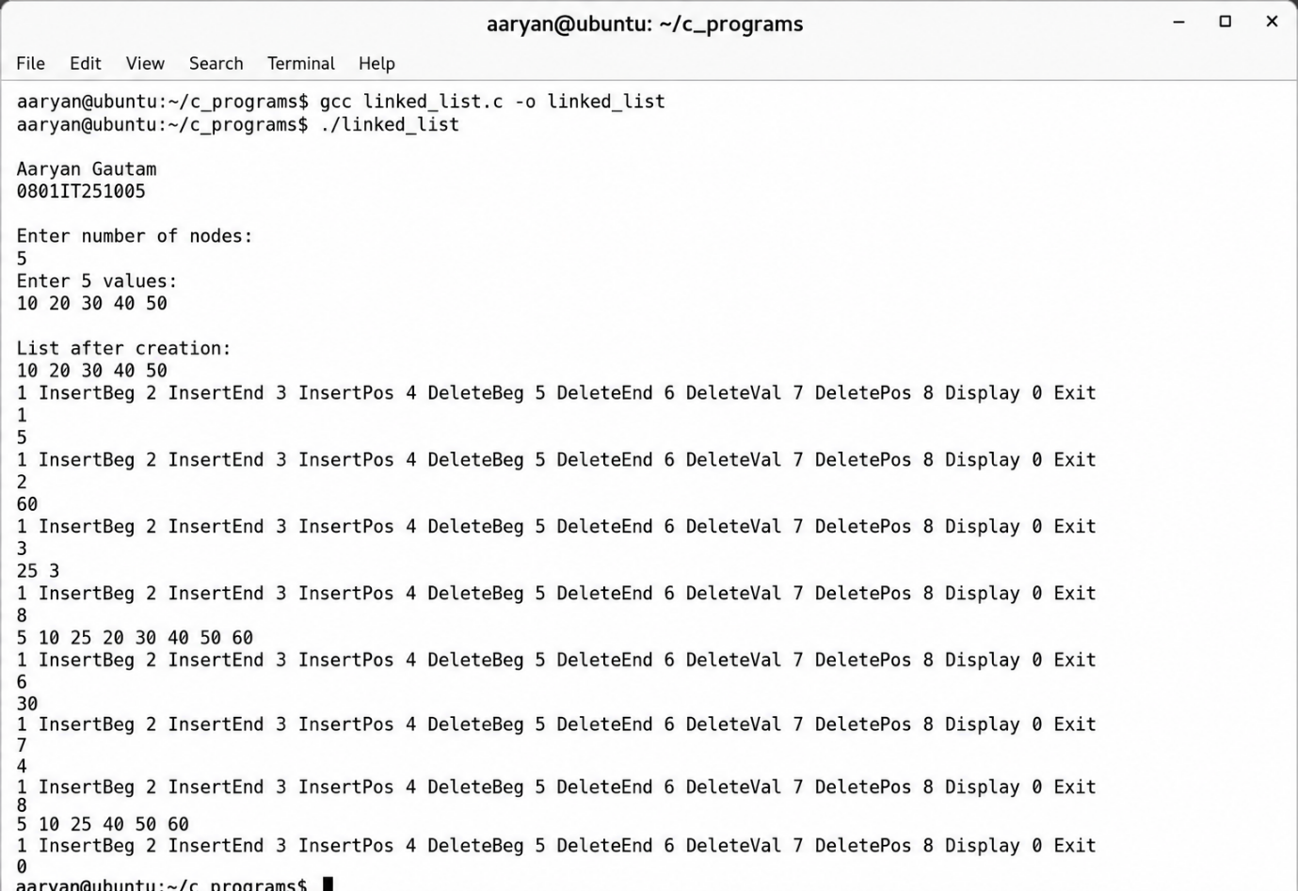

Q) Creation of Doubly Linked-List from user input and performing Traversal, Insertion and Deletion on the same through a menu based code.

#include<stdio.h>
#include<stdlib.h>
struct node{
int data;
struct node *prev;
struct node *next;
};
struct node *head=NULL;
void create(){
int n,i,val;
printf("Enter number of nodes:\n");
scanf("%d",&n);
printf("Enter %d values:\n",n);
for(i=0;i<n;i++){
scanf("%d",&val);
struct node *nn=(struct node*)malloc(sizeof(struct node));
nn->data=val;
nn->next=NULL;
nn->prev=NULL;
if(head==NULL)head=nn;
else{
struct node *temp=head;
while(temp->next!=NULL)temp=temp->next;
temp->next=nn;
nn->prev=temp;
}
}
}
void traverseF(){
struct node *temp=head;
if(temp==NULL){
printf("List is empty\n");
return;
}
while(temp!=NULL){
printf("%d ",temp->data);
temp=temp->next;
}
printf("\n");
}
void traverseB(){
if(head==NULL){
printf("List is empty\n");
return;
}
struct node *temp=head;
while(temp->next!=NULL)temp=temp->next;
while(temp!=NULL){
printf("%d ",temp->data);
temp=temp->prev;
}
printf("\n");
}
void insertBeg(int val){
struct node *nn=(struct node*)malloc(sizeof(struct node));
nn->data=val;
nn->prev=NULL;
nn->next=head;
if(head!=NULL)head->prev=nn;
head=nn;
}
void insertEnd(int val){
struct node *nn=(struct node*)malloc(sizeof(struct node));
nn->data=val;
nn->next=NULL;
if(head==NULL){
nn->prev=NULL;
head=nn;
return;
}
struct node *temp=head;
while(temp->next!=NULL)temp=temp->next;
temp->next=nn;
nn->prev=temp;
}
void insertPos(int val,int pos){
if(pos==1){
insertBeg(val);
return;
}
struct node *nn=(struct node*)malloc(sizeof(struct node));
nn->data=val;
struct node *temp=head;
int i;
for(i=1;i<pos-1 && temp!=NULL;i++)temp=temp->next;
if(temp==NULL){
printf("Invalid position\n");
free(nn);
return;
}
nn->next=temp->next;
nn->prev=temp;
if(temp->next!=NULL)temp->next->prev=nn;
temp->next=nn;
}
void deleteBeg(){
if(head==NULL){
printf("List is empty\n");
return;
}
struct node *temp=head;
head=head->next;
if(head!=NULL)head->prev=NULL;
free(temp);
}
void deleteEnd(){
if(head==NULL){
printf("List is empty\n");
return;
}
if(head->next==NULL){
free(head);
head=NULL;
return;
}
struct node *temp=head;
while(temp->next!=NULL)temp=temp->next;
temp->prev->next=NULL;
free(temp);
}
void deleteVal(int val){
if(head==NULL){
printf("List is empty\n");
return;
}
struct node *temp=head;
while(temp!=NULL && temp->data!=val)temp=temp->next;
if(temp==NULL){
printf("Value not found\n");
return;
}
if(temp->prev!=NULL)temp->prev->next=temp->next;
else head=temp->next;
if(temp->next!=NULL)temp->next->prev=temp->prev;
free(temp);
}
void deletePos(int pos){
if(head==NULL){
printf("List is empty\n");
return;
}
struct node *temp=head;
int i;
for(i=1;i<pos && temp!=NULL;i++)temp=temp->next;
if(temp==NULL){
printf("Invalid position\n");
return;
}
if(temp->prev!=NULL)temp->prev->next=temp->next;
else head=temp->next;
if(temp->next!=NULL)temp->next->prev=temp->prev;
free(temp);
}
int main(){
printf("Atharv Shukla\n0801IT251033\n");
int ch,val,pos;
create();
printf("List after creation:\n");
traverseF();
while(1){
printf("1 InsertBeg 2 InsertEnd 3 InsertPos 4 DeleteBeg 5 DeleteEnd 6 DeleteVal 7 DeletePos 8 DisplayForward 9 DisplayBackward 0 Exit\n");
scanf("%d",&ch);
if(ch==1){
scanf("%d",&val);
insertBeg(val);
}
else if(ch==2){
scanf("%d",&val);
insertEnd(val);
}
else if(ch==3){
scanf("%d %d",&val,&pos);
insertPos(val,pos);
}
else if(ch==4)deleteBeg();
else if(ch==5)deleteEnd();
else if(ch==6){
scanf("%d",&val);
deleteVal(val);
}
else if(ch==7){
scanf("%d",&pos);
deletePos(pos);
}
else if(ch==8)traverseF();
else if(ch==9)traverseB();
else break;
}
return 0;
}
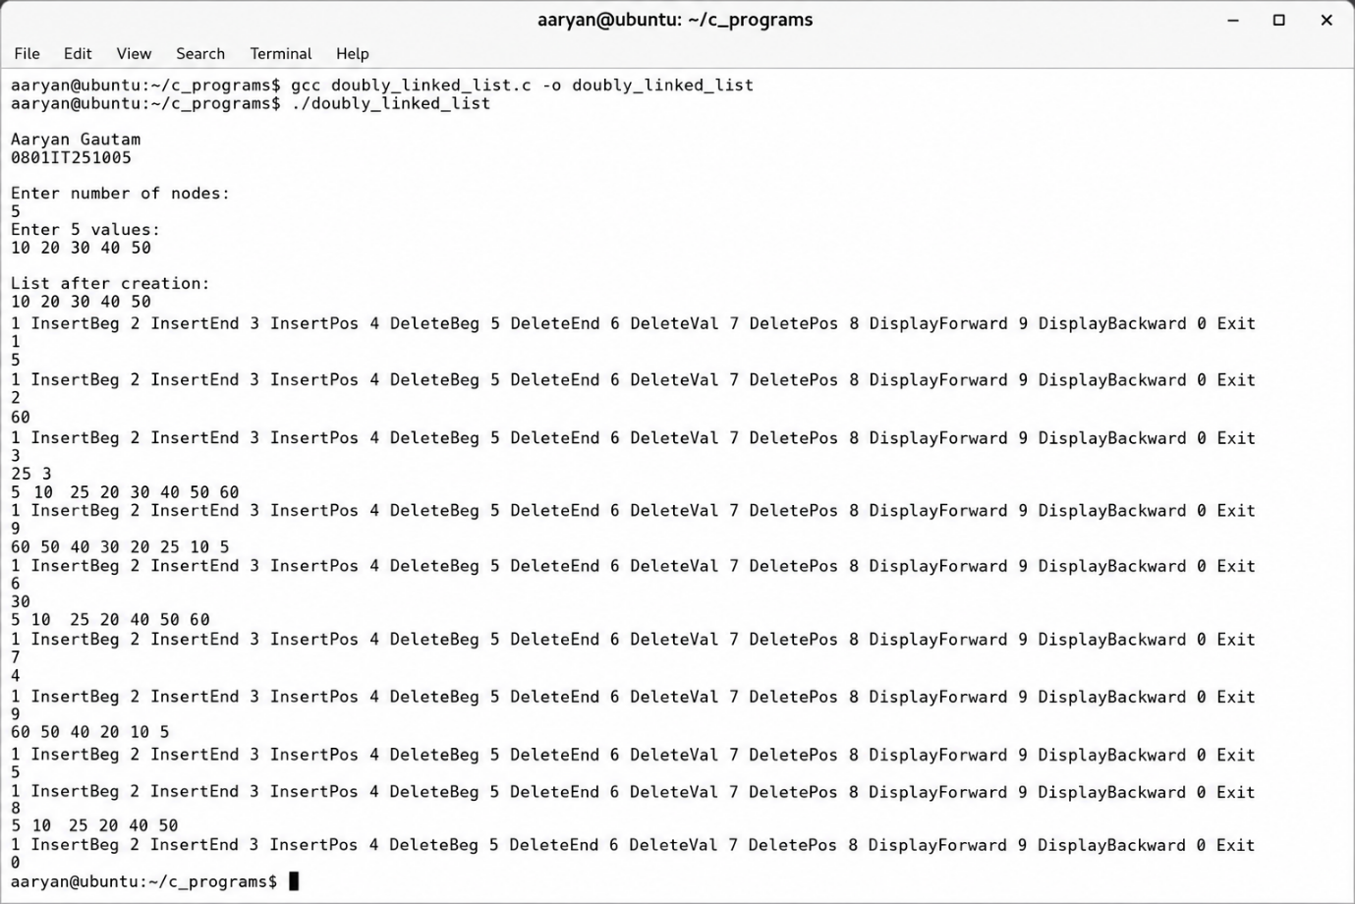

Q) Write a complete C program using dynamic memory allocation that performs the following operations:
- Prompt the user to input the total number of elements (N) and the corresponding array values, then dynamically allocate memory, store the values, and print the array.
- Reverse the elements of the array in place and print the reversed array.
- Calculate and print the sum of all elements in the array.
Ensure proper memory management by freeing the allocated memory before the program terminates.

#include<stdio.h>
#include<stdlib.h>
int main(){
printf("Atharv Shukla\n0801IT251033\n");
int n,i,sum=0;
printf("Enter number of elements:\n");
scanf("%d",&n);
int *arr=(int*)malloc(n*sizeof(int));
printf("Enter %d elements:\n",n);
for(i=0;i<n;i++)scanf("%d",&arr[i]);
printf("Original array:\n");
for(i=0;i<n;i++)printf("%d ",arr[i]);
for(i=0;i<n/2;i++){
int t=arr[i];
arr[i]=arr[n-1-i];
arr[n-1-i]=t;
}
printf("\nReversed array:\n");
for(i=0;i<n;i++)printf("%d ",arr[i]);
for(i=0;i<n;i++)sum+=arr[i];
printf("\nSum=%d\n",sum);
free(arr);
return 0;
}
